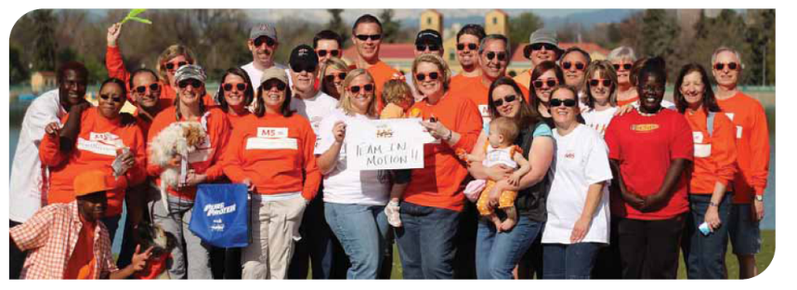
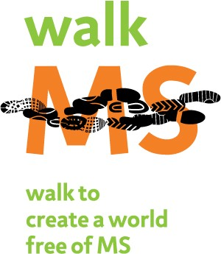

<Date>
To the Editor:

On <date> I will be joining my fellow <your town> residents on a special journey – Walk MS <your exact Walk MS site>. This event is very important to me because it raises awareness and money to work toward a world free of multiple sclerosis, a chronic disease of the central nervous system. There is no cure for this disease, which is why I am participating in Walk MS <your exact Walk MS site> and asking my neighbors and community members to help me raise awareness and funds.

I am walking because <personal connection to MS. ex. I have MS; My mother has MS>, and the Upstate New York Chapter has provided programs and emotional support when we have needed it most. Participating in Walk MS <your exact Walk MS site> is how I can make a difference and give back. This is why I walk. Please join me <date> and do what you can to move toward a world free of MS.

Walk MS <your exact Walk MS site> takes place <date> in <location>. It is organized by the National Multiple Sclerosis Society Upstate New York Chapter. The chapter’s goal is to raise $1.364 million. Money raised will fund programs and services for people with MS and their families in 50 counties throughout Upstate New York. This includes support groups, newly diagnosed programs, crisis counseling, equipment loans, and many more, as well as vital research. There are many ways we can all help out this worthwhile cause:

Walk.
Registration is easy. You can sign up online at www.msupstateny.org or by calling 1-800-FIGHT-MS (press 2).

Volunteer.
Call 1-800-FIGHT-MS (press 2) and ask for Ashley Greenman, Manager of Volunteer Engagement, or sign up online at www.msupstateny.org.

Donate.
Go to www.msupstateny.org and donate online. You can sponsor a specific walker or team, or make a general donation.

<Name>
<Neighborhood or town>

